**VPC WITH WINDOWS AMI**

1.Create a VPC

2.Create a public subnet with cidr 10.0.1.0/24

3.create a private subnert with cidr 10.0.2.0/24

->to create the bastion server

->give the name of the instance as WINDOWS-WEB

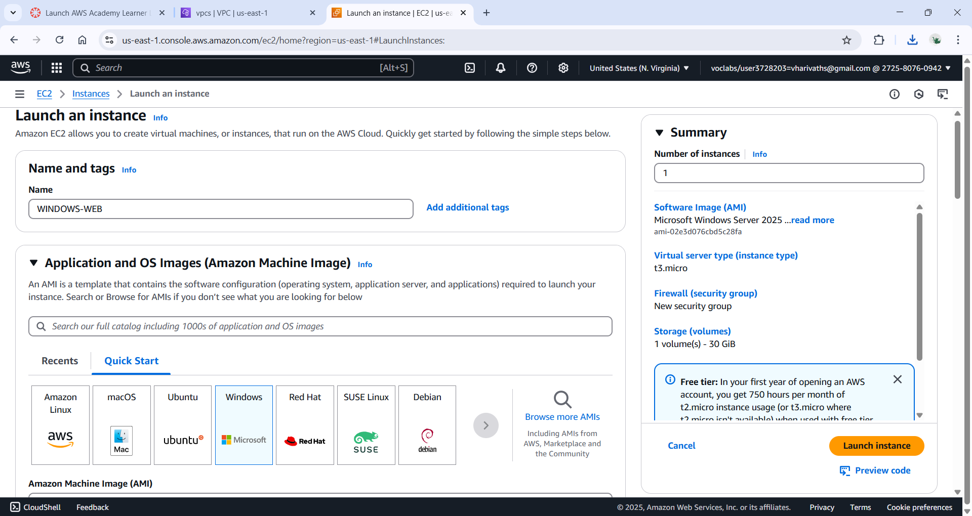

->select the ami as windows as we are working on windows

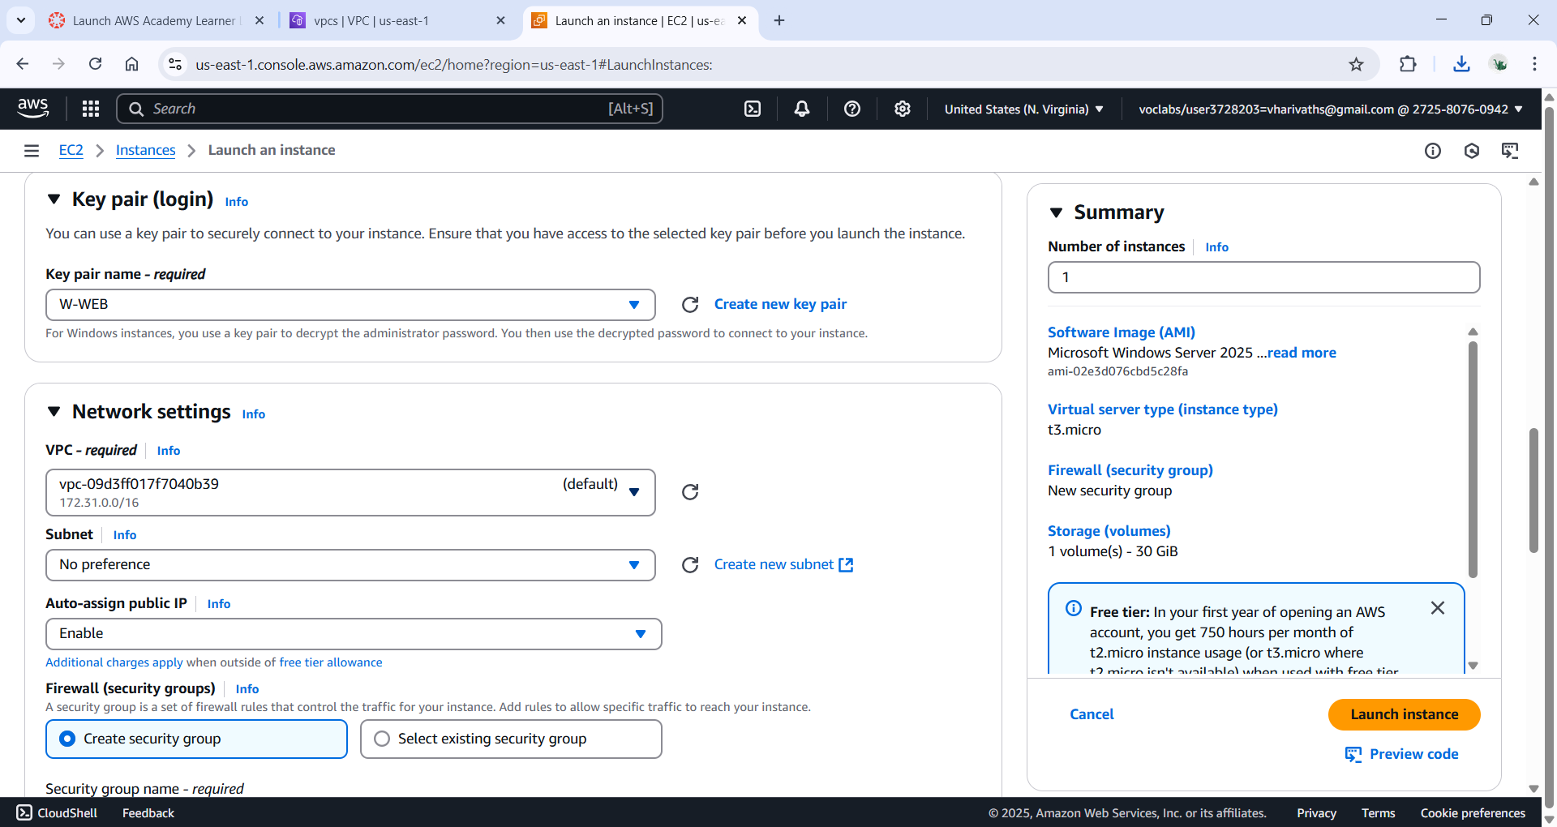

->create a pem key pair for the web

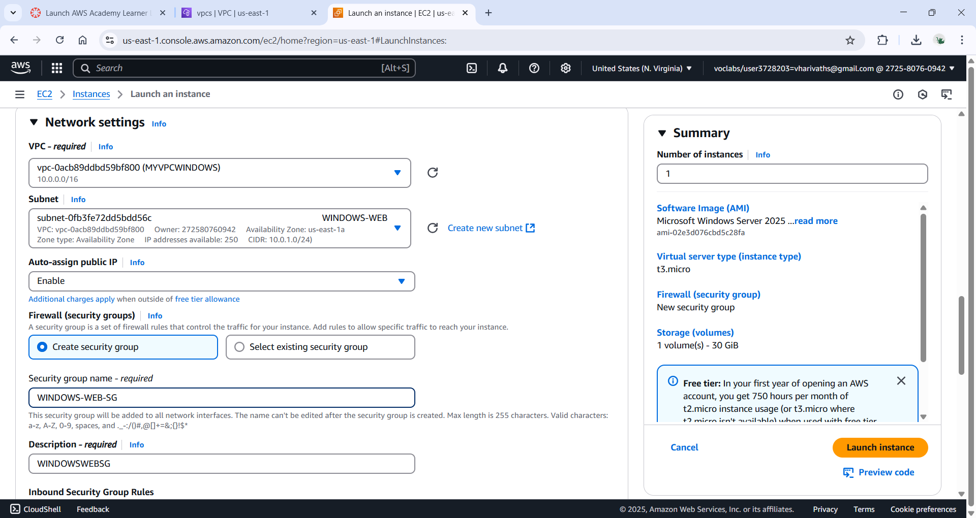

->edit the network settings and select the vpc

->choose the subnet as the webserver

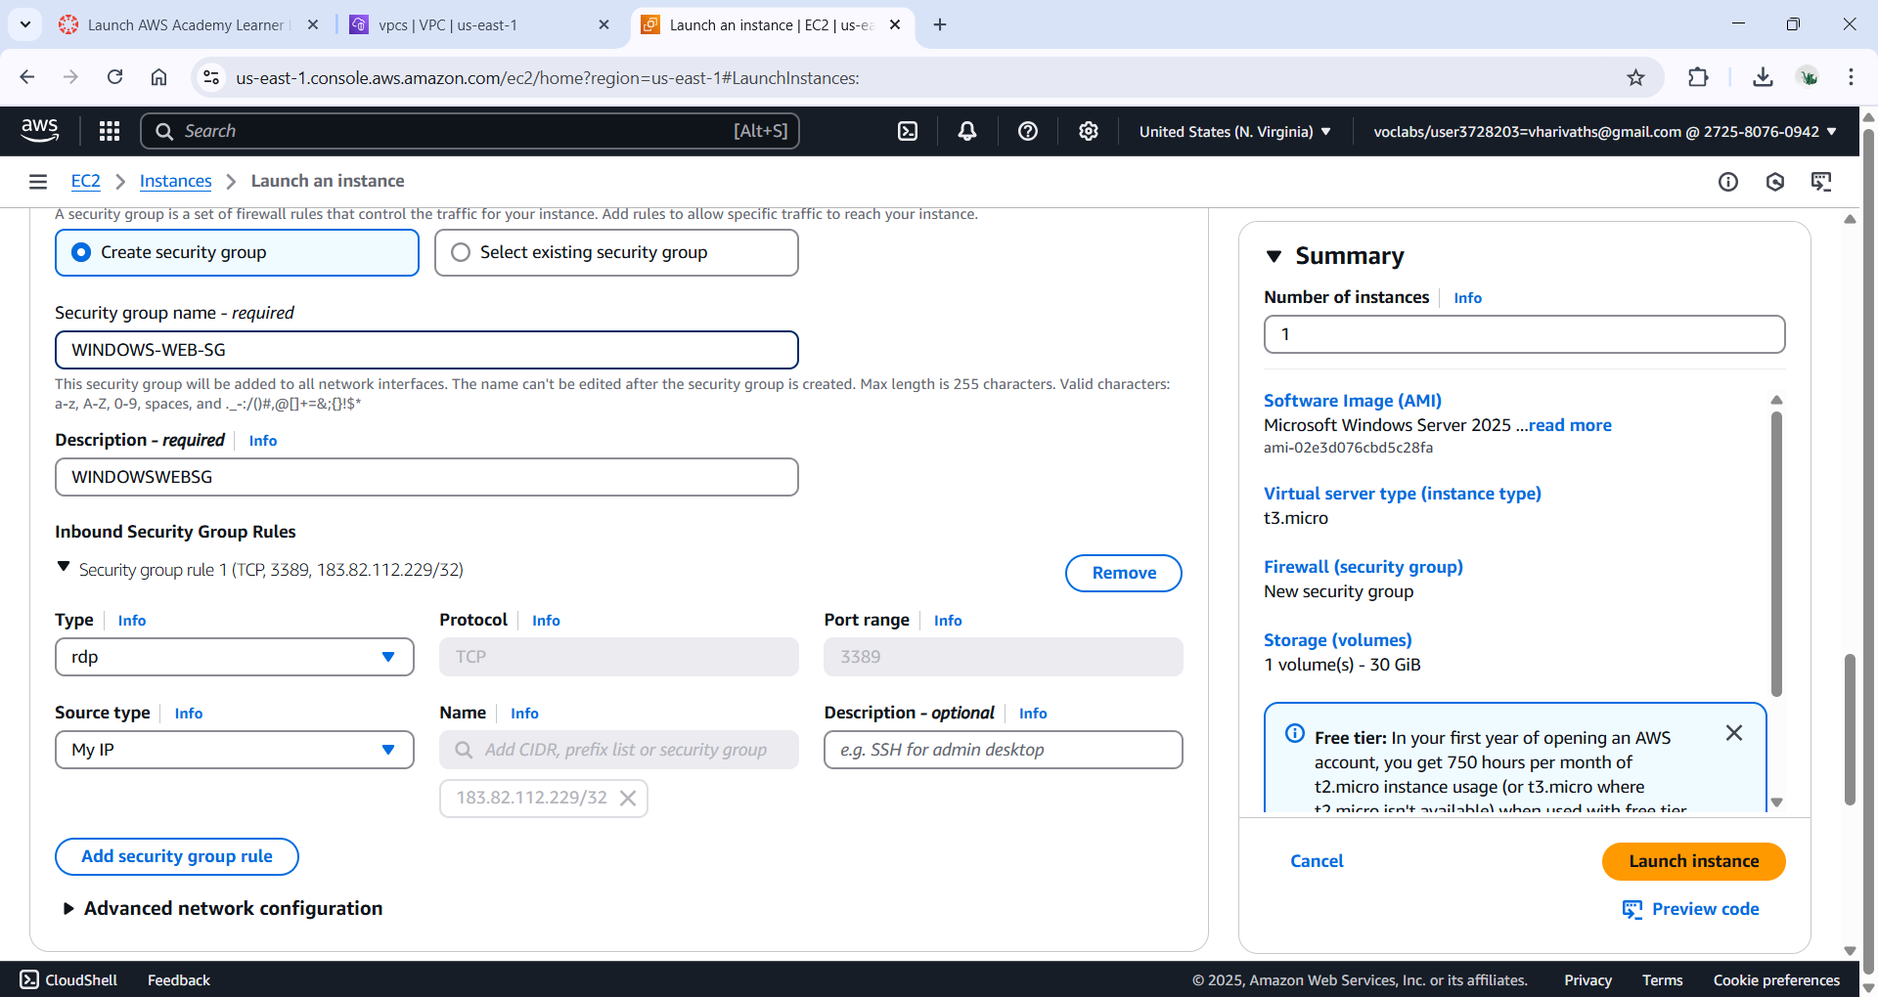

-> in the network setting edit the network settings.

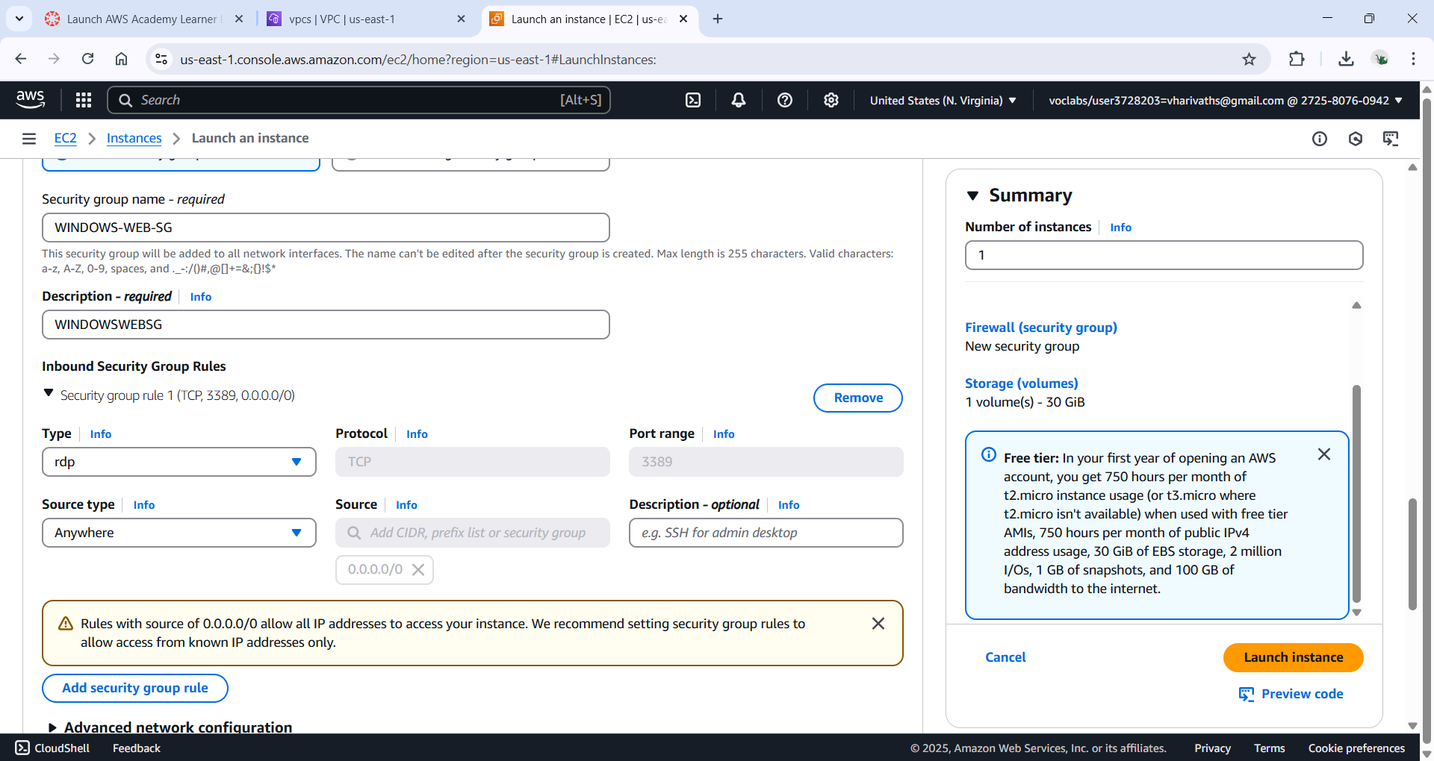

->review and launch.

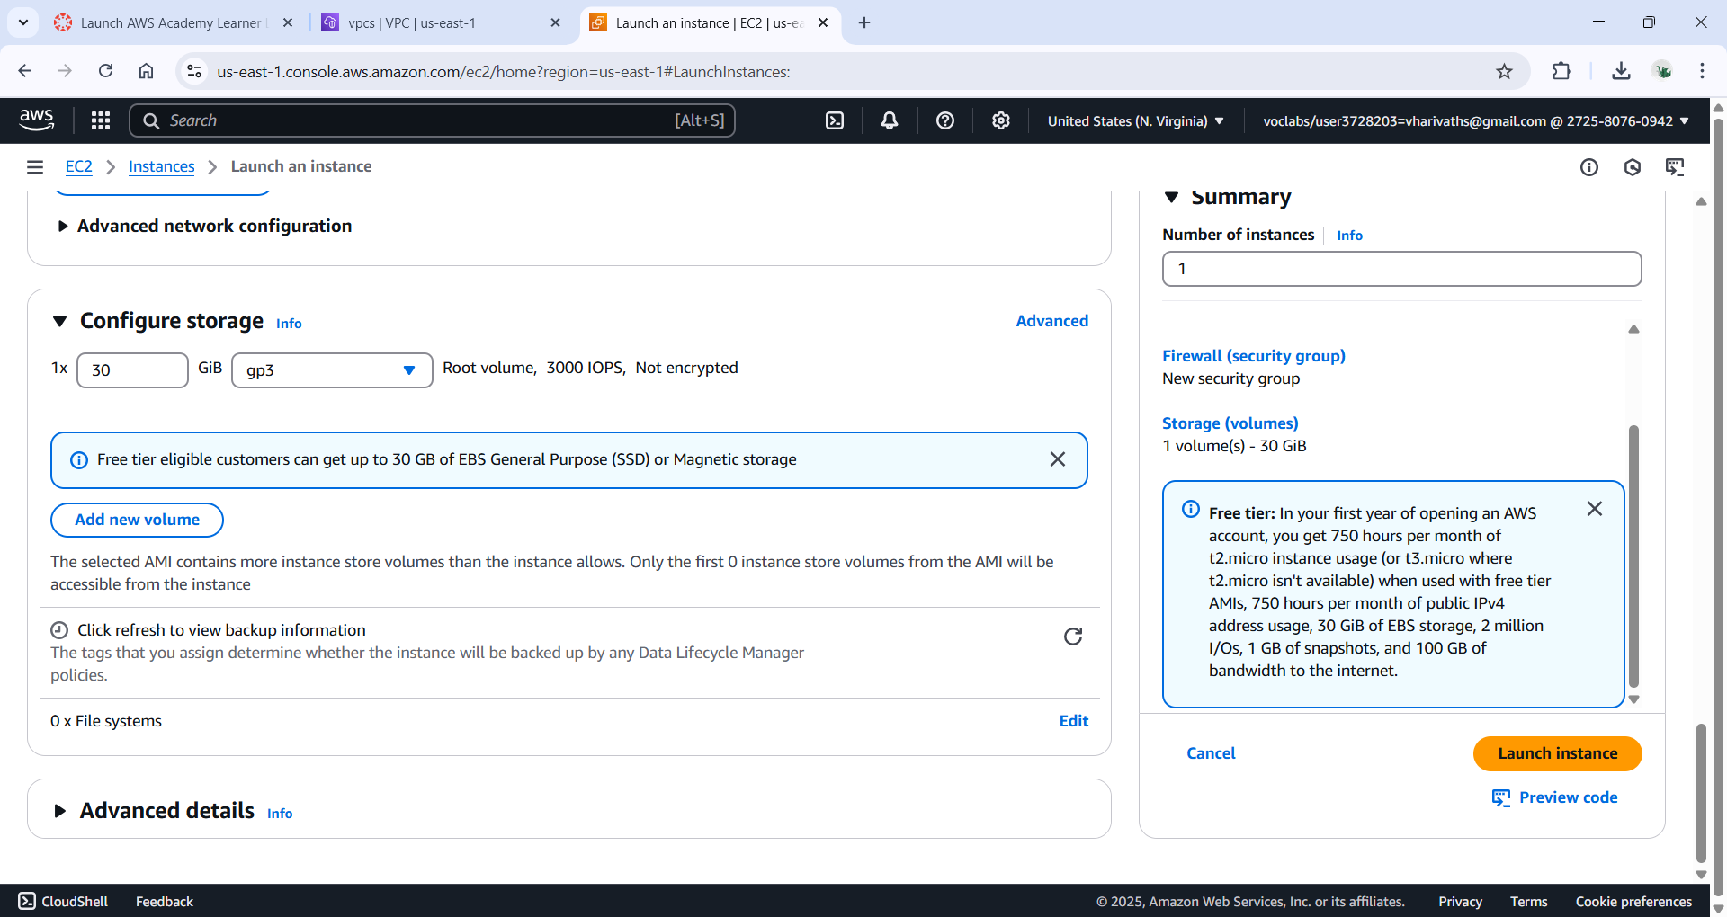

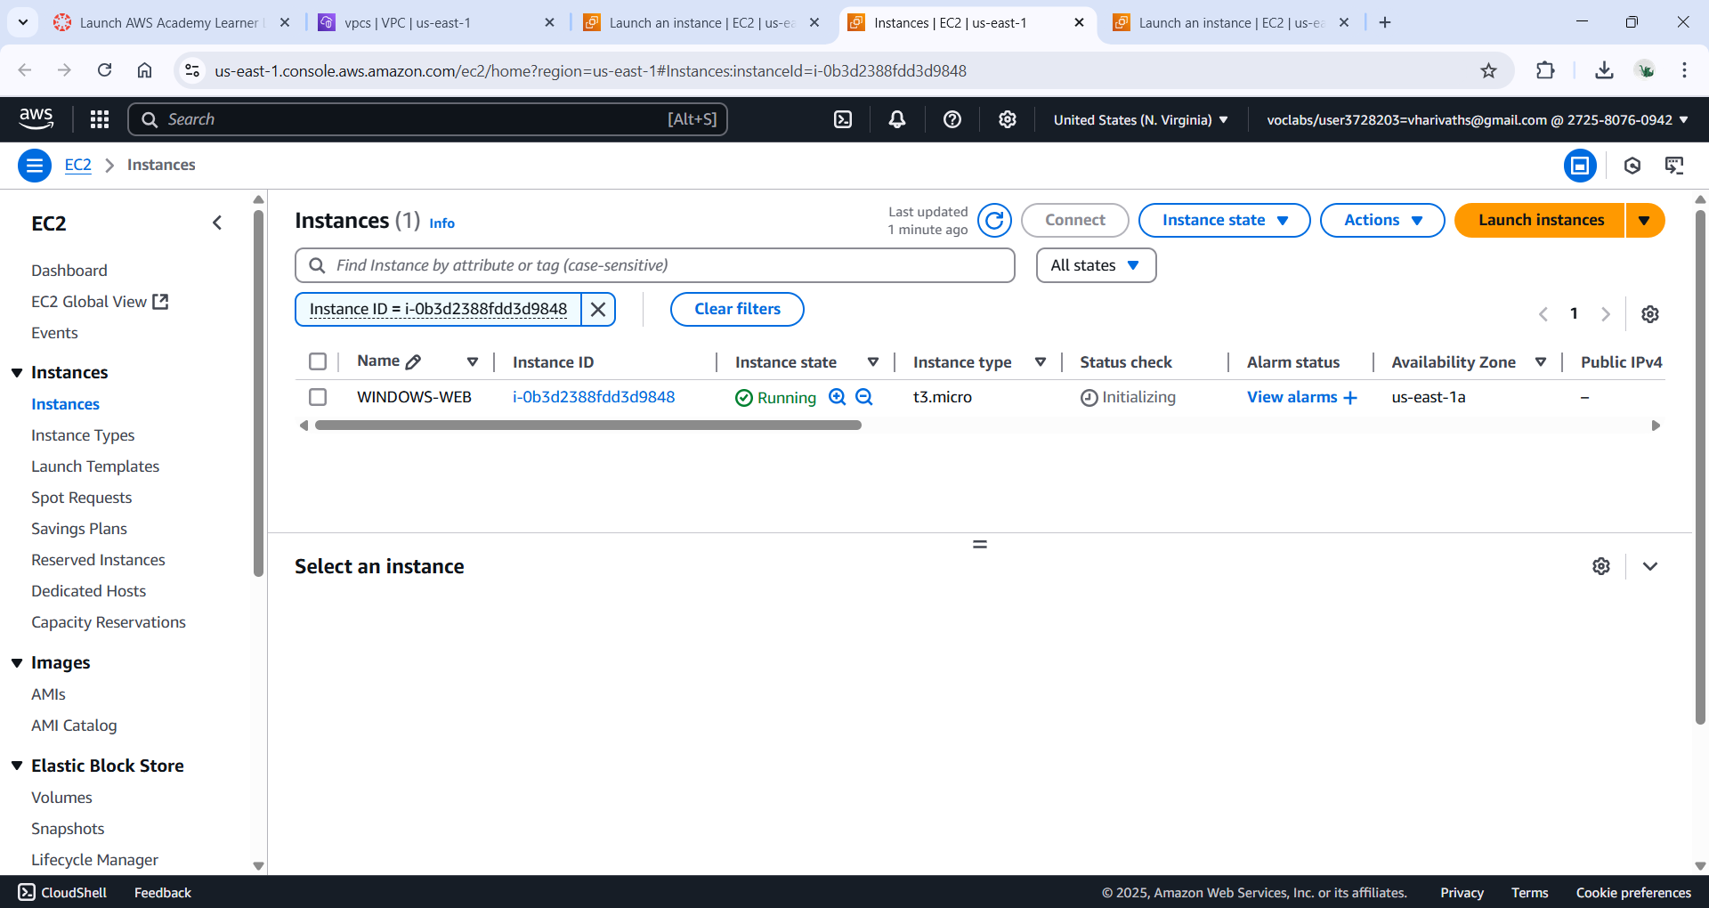

->to create the bastion server

->give the name of the instance as bastionserver

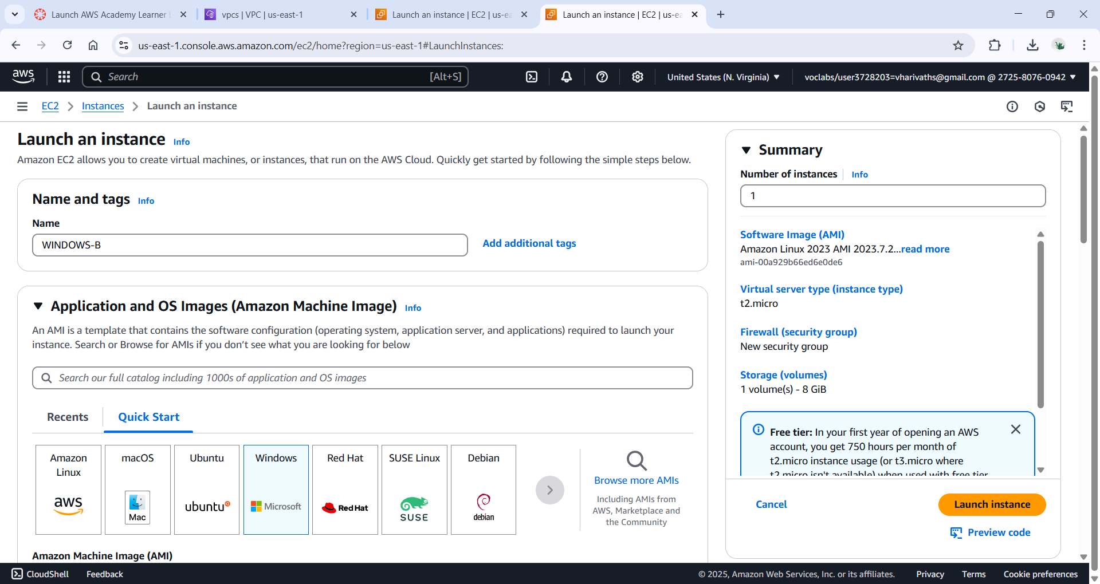

->select the ami as windows as we are working on windows

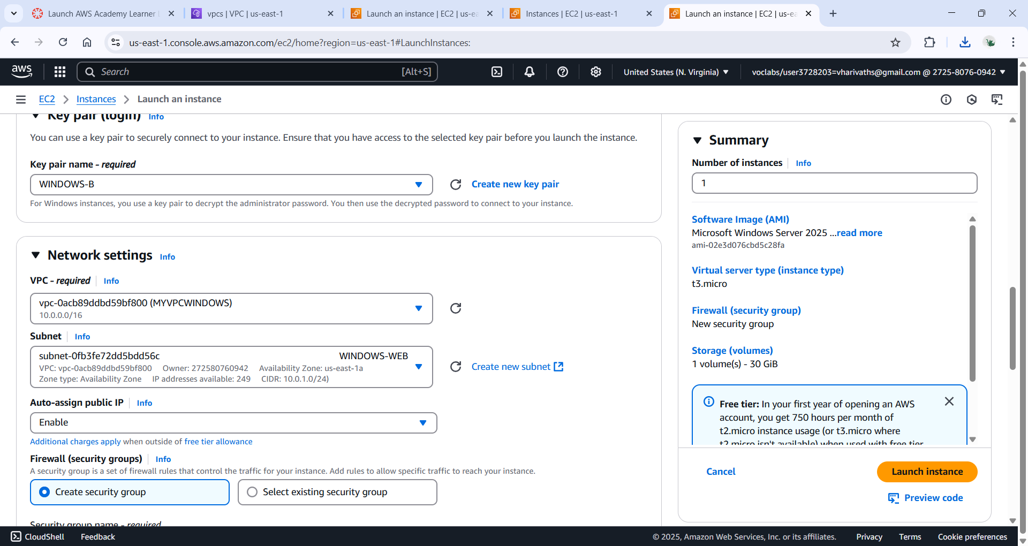

->create a pem key pair for the bastion server

->edit the network settings and select the vpc

->choose the subnet as the webserver

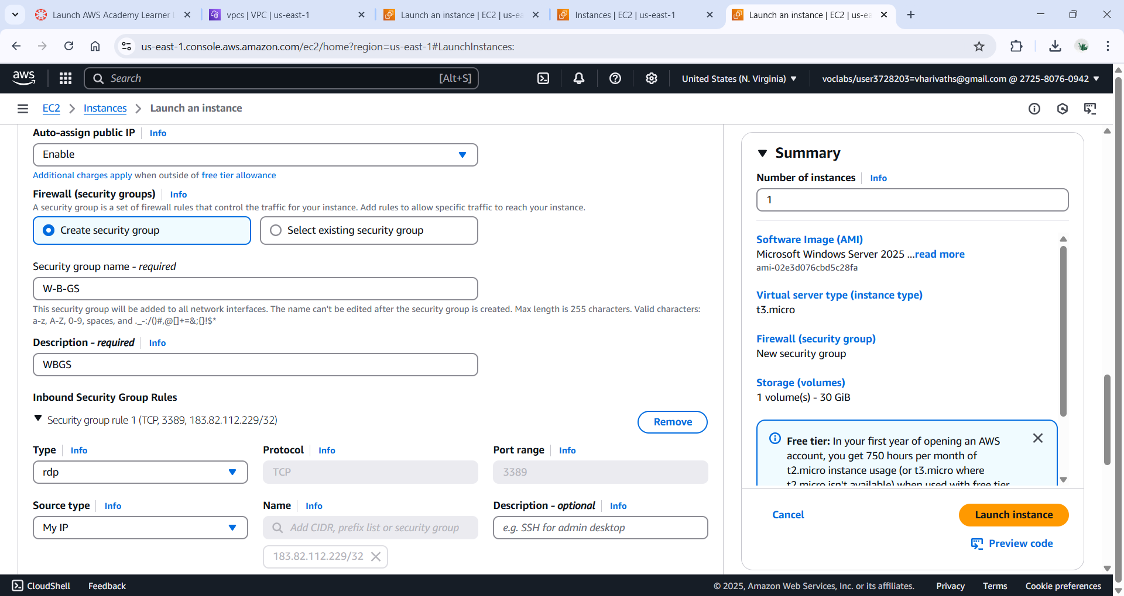

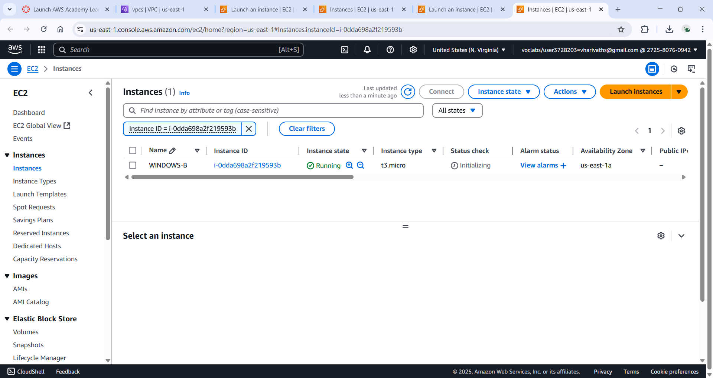

->To create the db server

->Give the name of the instance as db server and the ami as windows

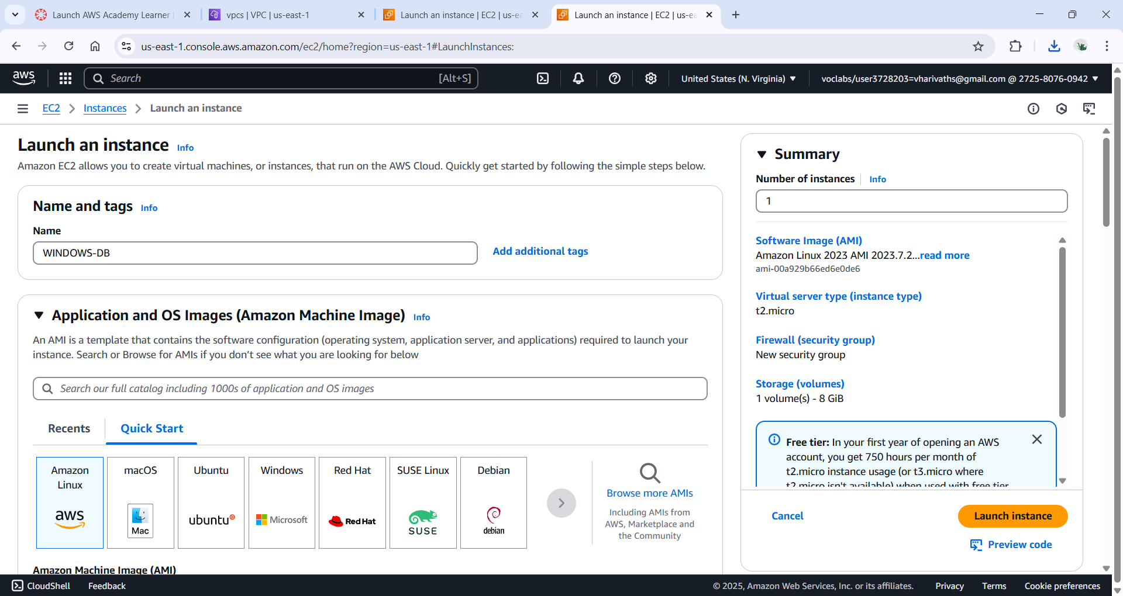

->create the pem key for the db server

->In the network setting edit the network settings and choose the required vpc

->Select the subnet as db for db server

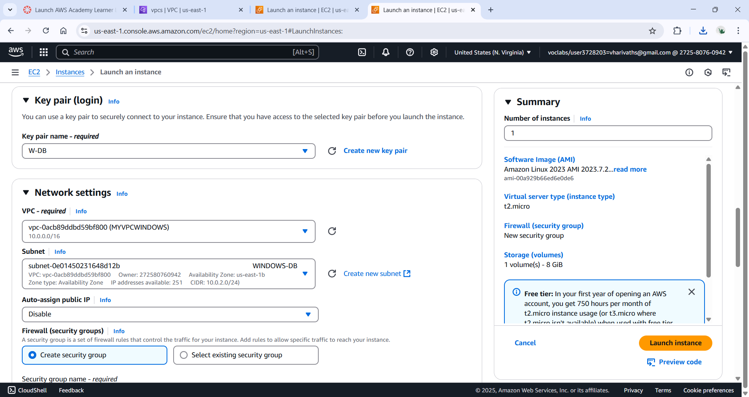

-> in the network setting edit the network settings and choose the source type as custom and foe the source give the private ipv4 address of the bastion server

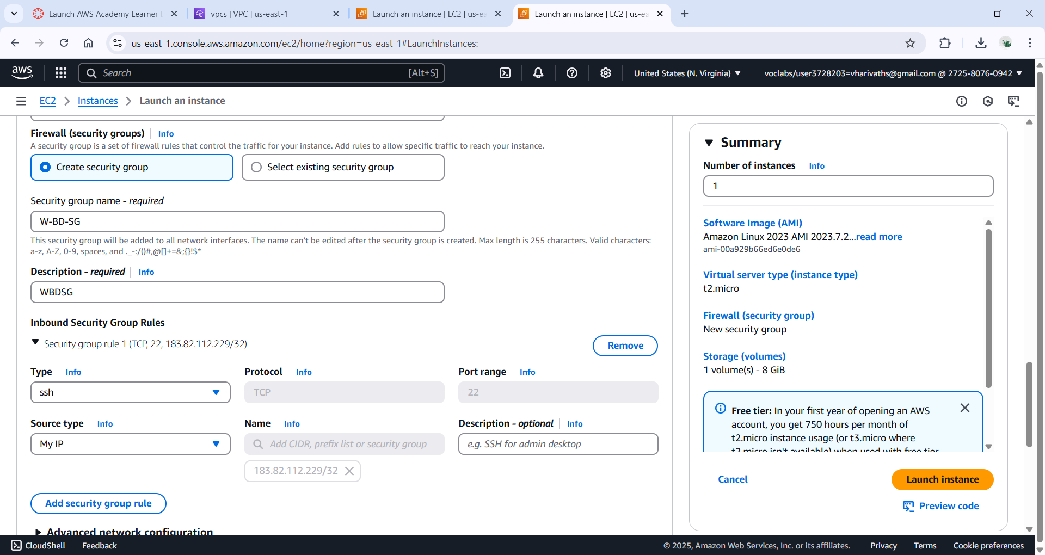

->now launch the instance

->go to the rdp client

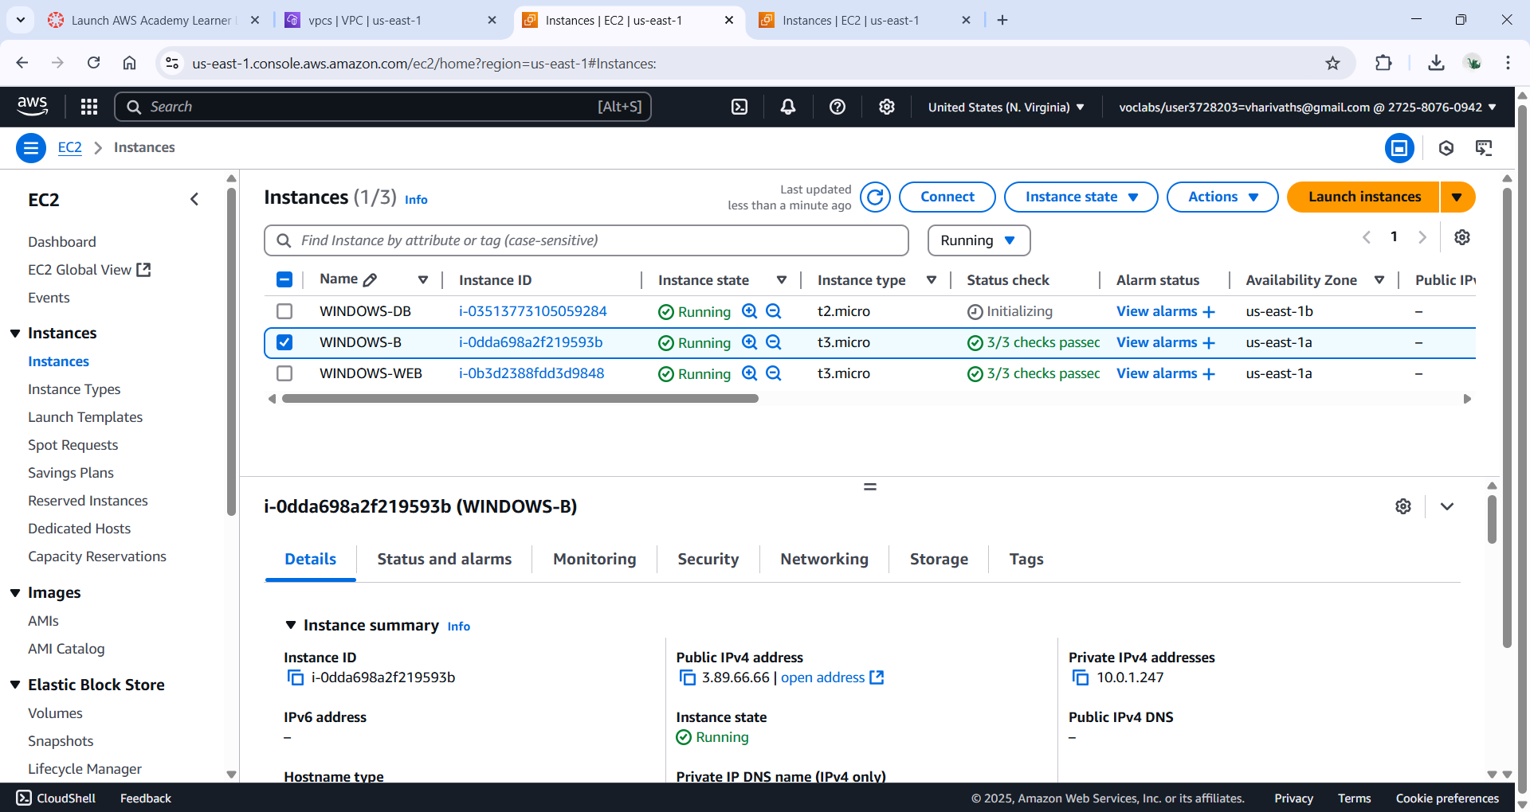

->now select the download remote desktop file

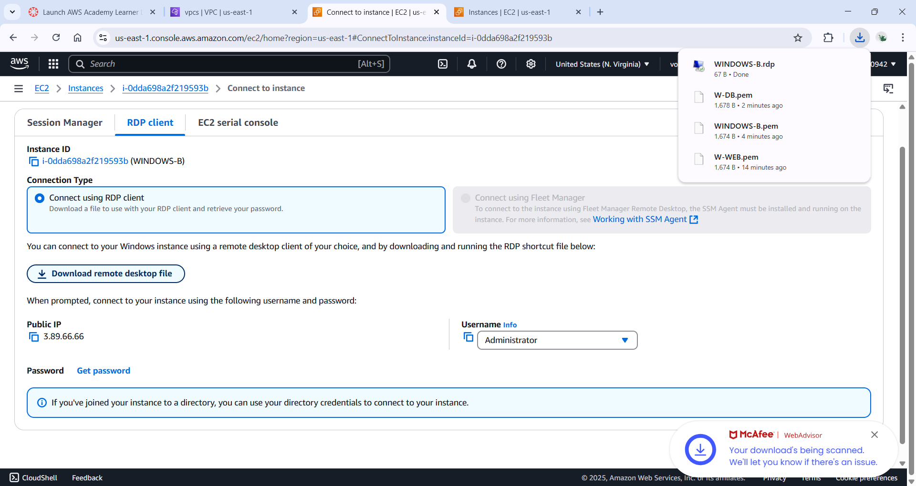

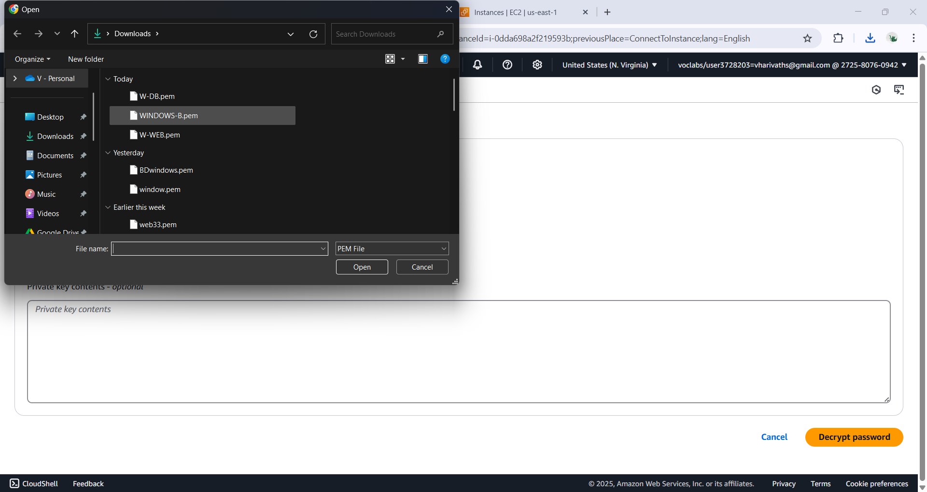

->now to get password form keypair

->now decrypt the password

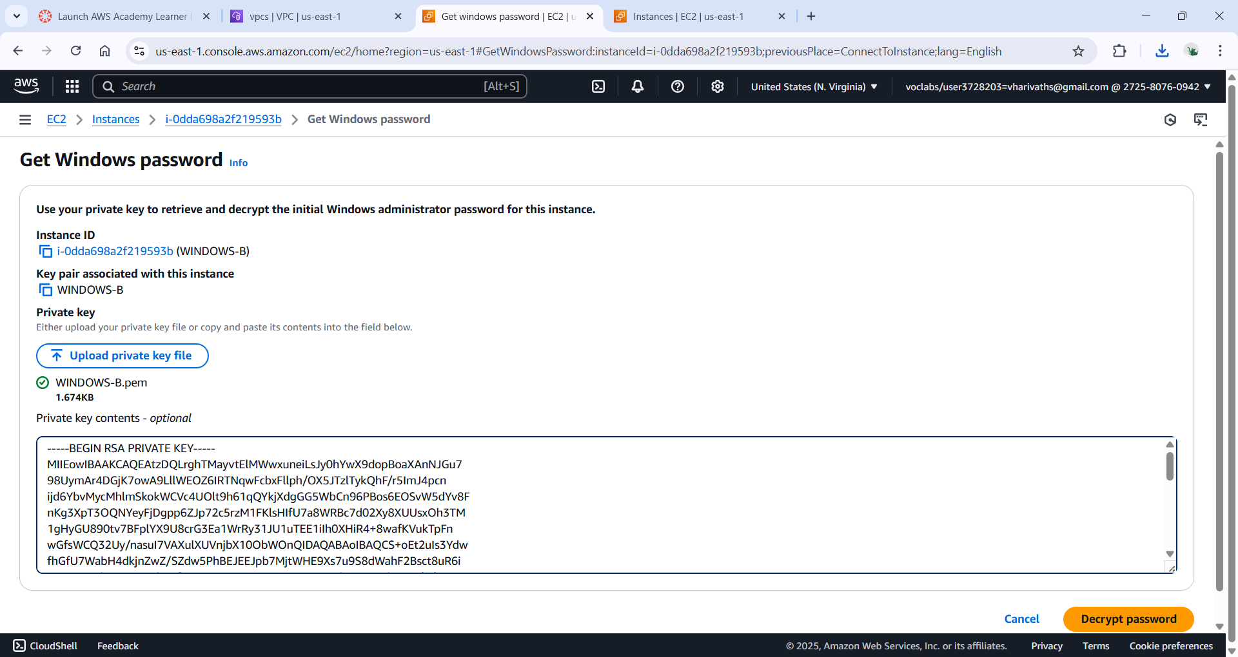

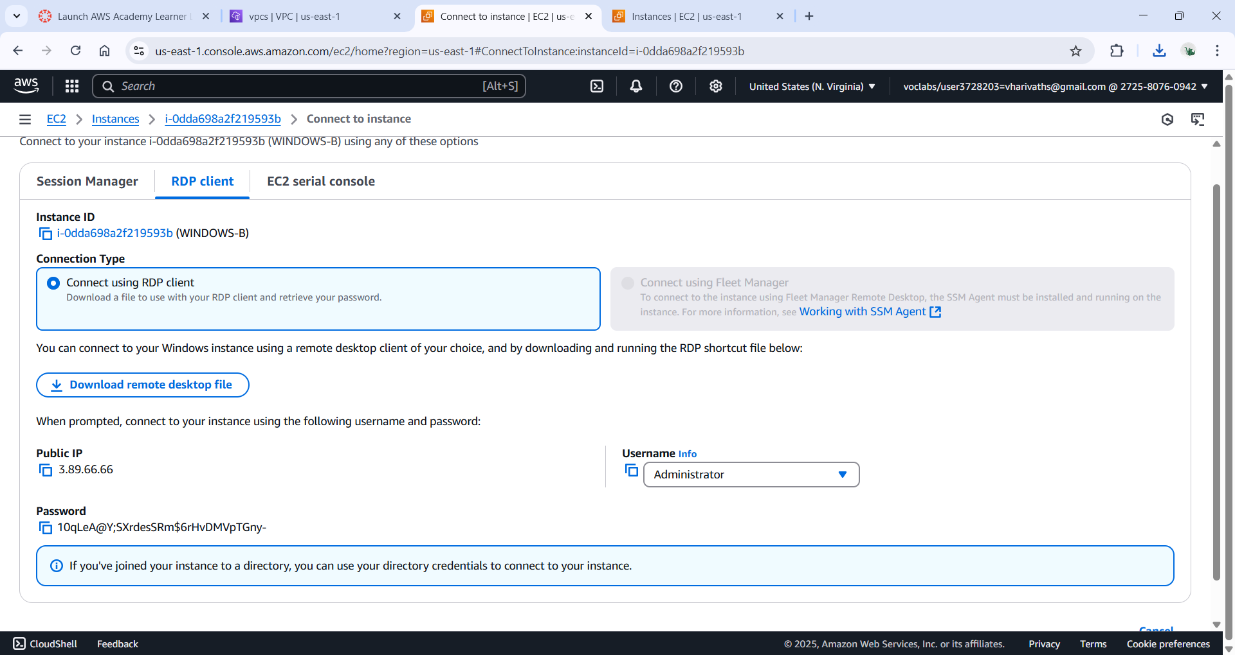

->now click on Downloaded remote file

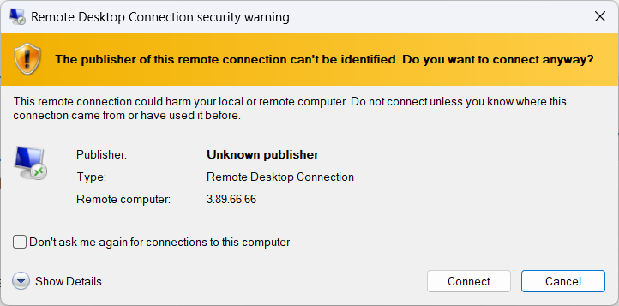

->click on Connect

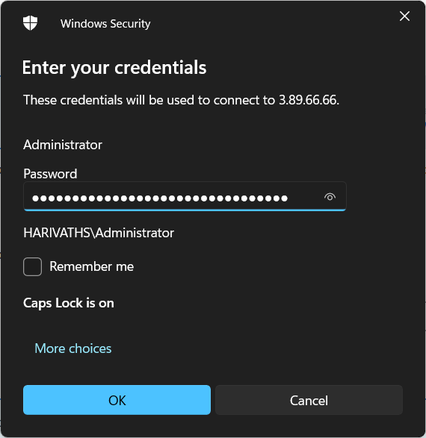

->now enter the password

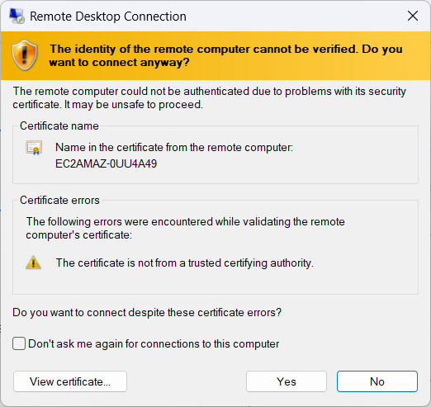

->click on yes

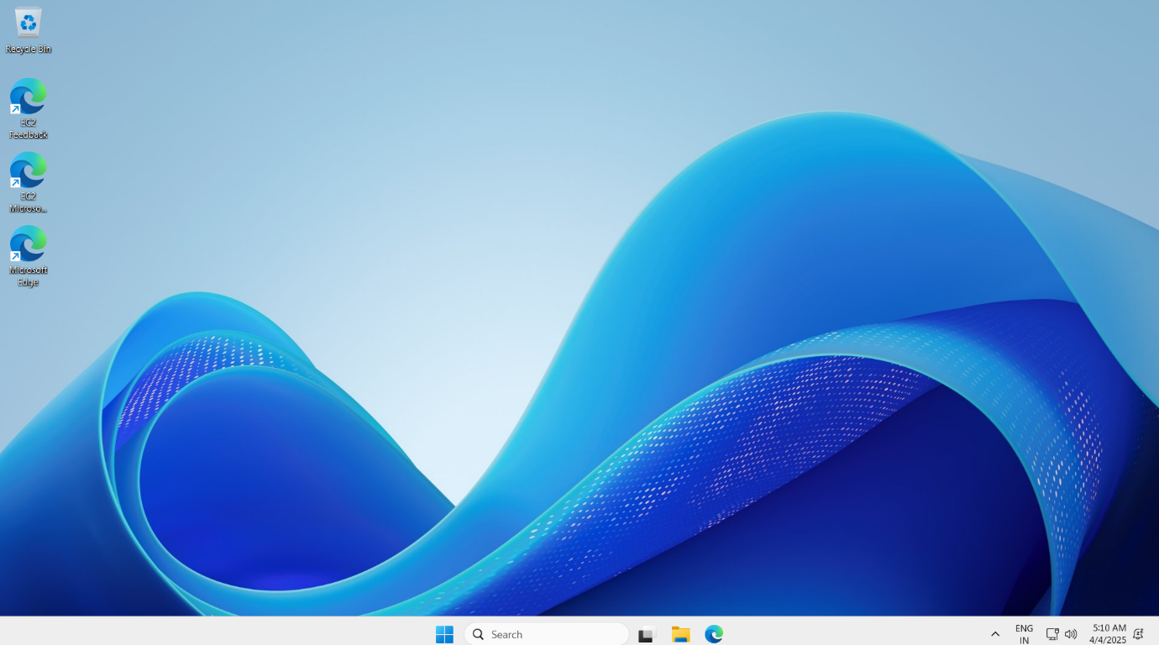

->now copy the private ipv4 address of the db seerrver and get the password

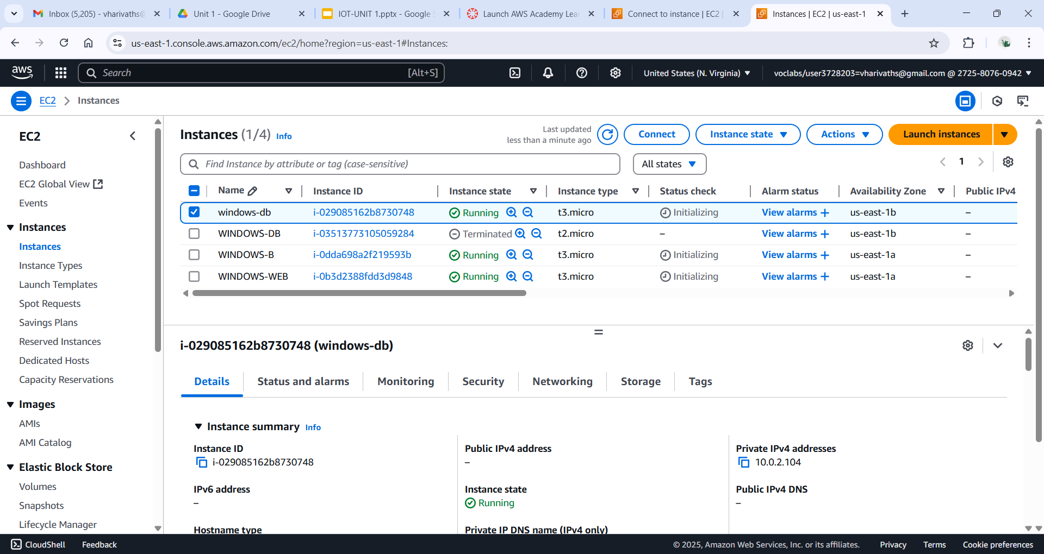

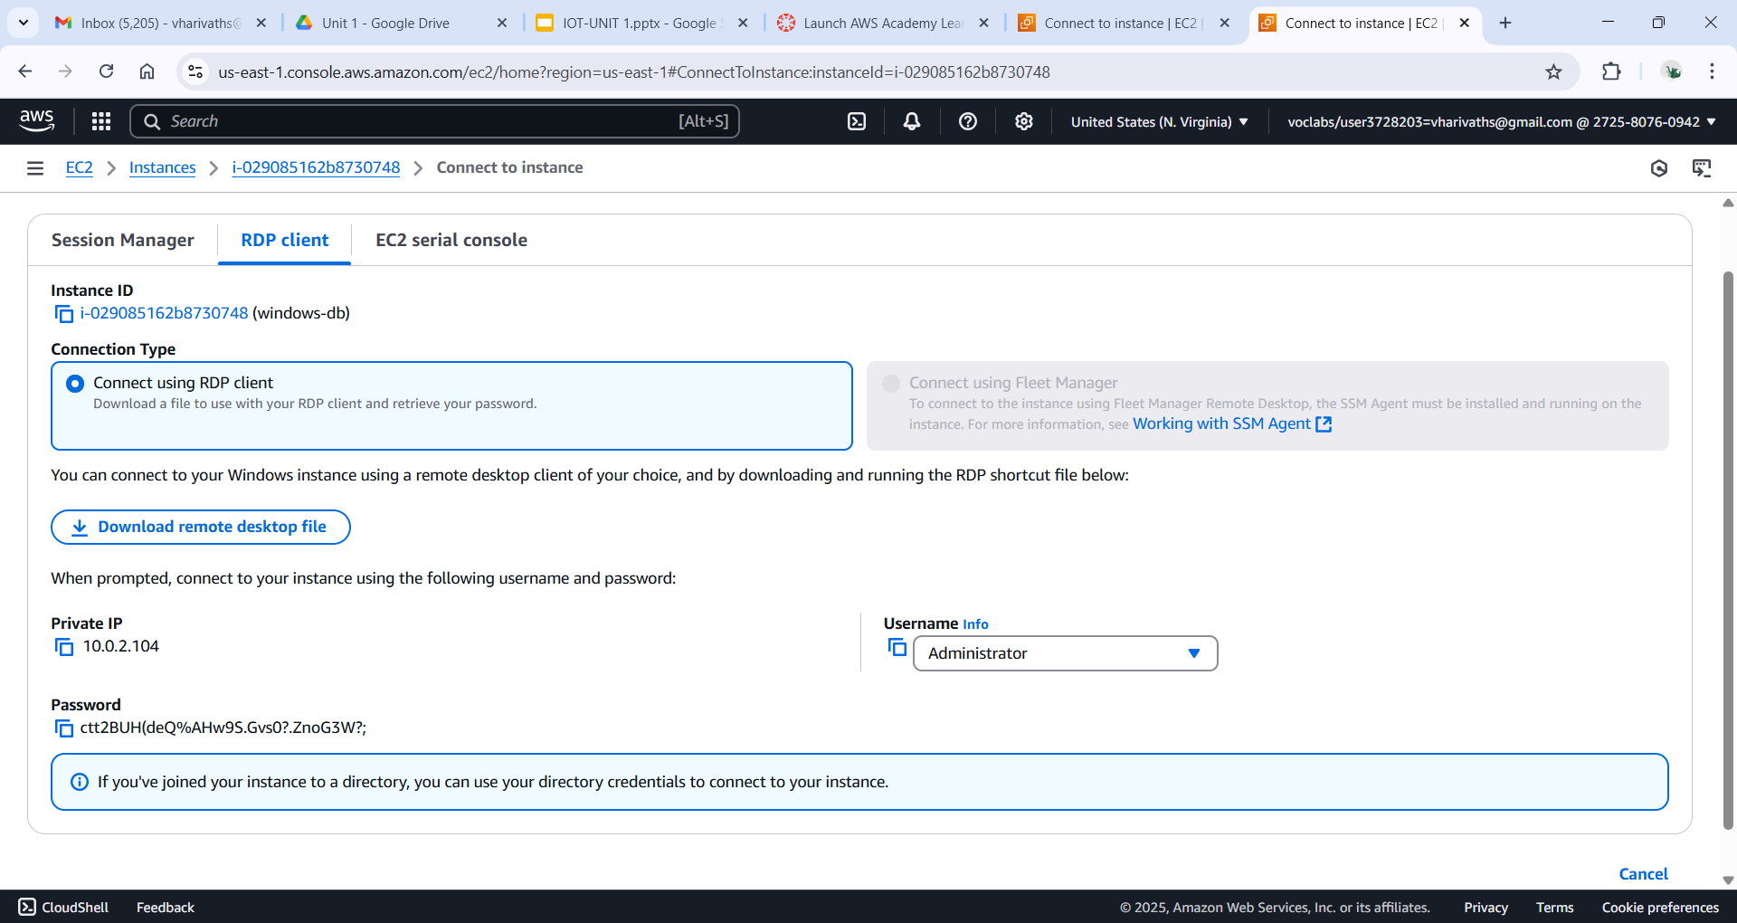

->now search for rdp in the taskbar

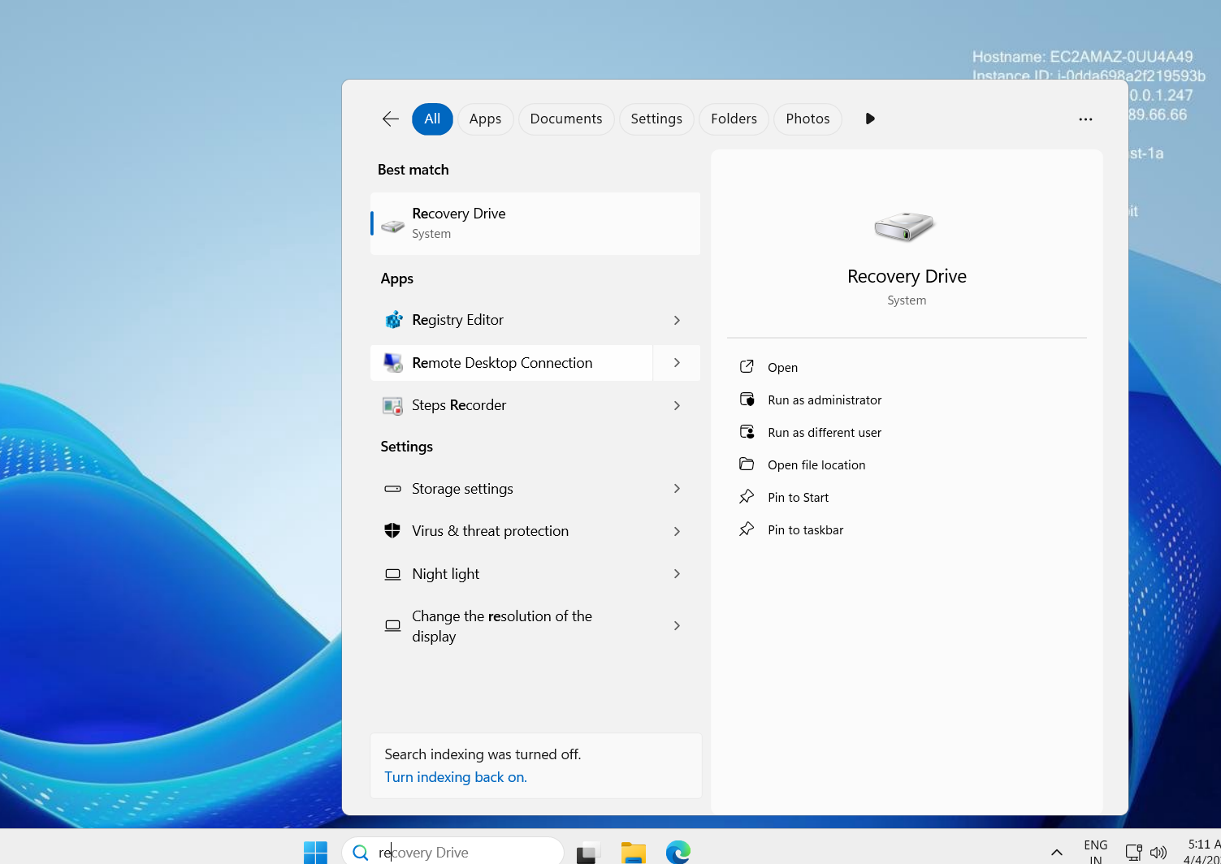

->give the private ipv4 adress of the db server and connect

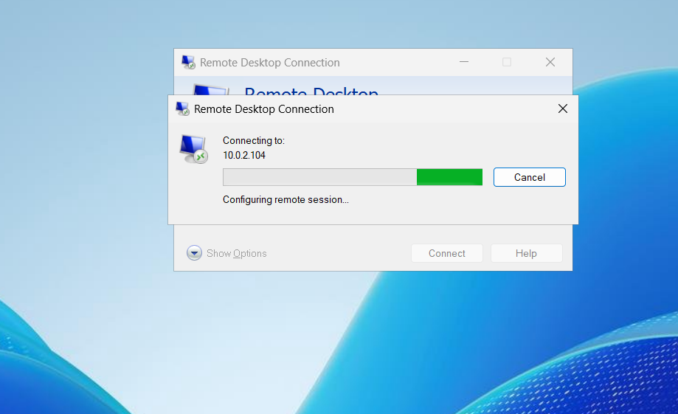

->after connecting to the db server

->now we can see that the net has been connected

->now go to miscrosoft edge and search

